Solomon Adjustment Calculators Recommended Commentary

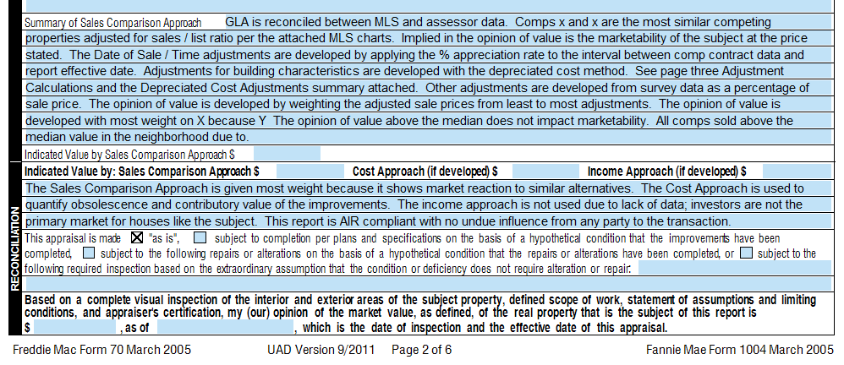
These are my standard comments for page 2 of the URAR. I begin with this and edit as necessary.

Summary of Sales Comparison Approach

GLA is reconciled between MLS and assessor data.

Comps x and x are the most similar competing properties adjusted for sales / list ratio per the attached MLS charts.

Implied in the opinion of value is the marketability of the subject at the price stated.

The Date of Sale / Time adjustments are developed by applying the x% appreciation rate to the interval between comp contract data and report effective date.

Adjustments for building characteristics are developed with the depreciated cost method. See page three Adjustment Calculations and the Depreciated Cost Adjustments summary attached.

(I include a screen shot of Solomon Cost as a page in the report titled Depreciated Replacement Cost Adjustment Calculations)

Other adjustments are developed from survey data as a percentage of sale price.

The opinion of value is developed by weighting the adjusted sale prices from least to most adjustments.

Alternate:

The opinion of value is developed with most weight on X because Y

The opinion of value above/below the median does not impact marketability. All comps sold above/below the median value in the neighborhood due to x.

Reconciliation

The Sales Comparison Approach is given most weight because it shows market reaction to similar alternatives. The Cost Approach is used to quantify obsolescence and contributory value of the improvements. The income approach is not used due to lack of data; investors are not the primary market for houses like the subject. This report is AIR compliant with no undue influence from any party to the transaction.

Notice that the Cost Approach is not being used as an approach to value. The Cost Approach is being used to measure depreciation.

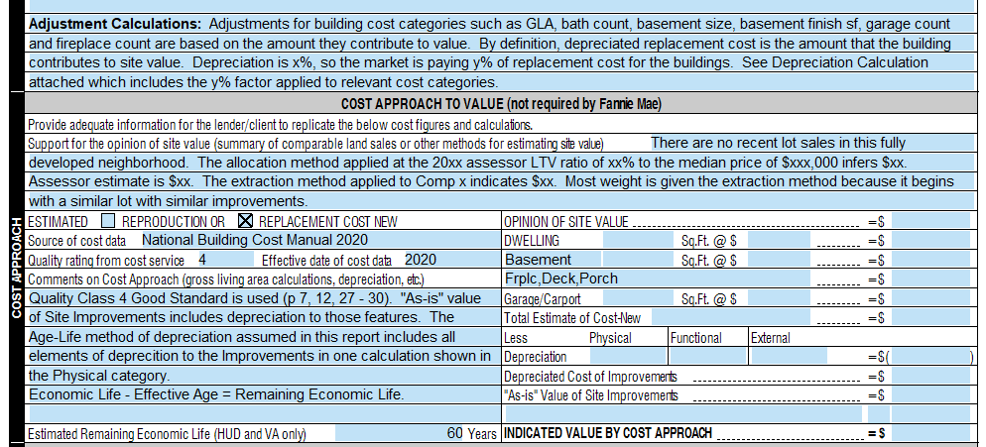
These are my standard comments for page 3 of the URAR

Just above the Cost Approach to Value I include this:
Adjustment Calculations: Adjustments for building cost categories such as GLA, bath count, basement size, basement finish sf, garage count and fireplace count are based on the amount they contribute to value. By definition, depreciated replacement cost is the amount that the building contributes to site value. Depreciation is 33%, so the market is paying 67% of replacement cost for the buildings. See Depreciation Calculation attached which includes the 67% factor applied to relevant cost categories. (Edit the categories and numbers as needed)
Support for the opinion of site value (summary of comparable land sales or other methods for estimating site value)

If I have land sales, I summarize those here and add a screen shot of them to the report.

If there are no land sales, I state that before I discuss other methods.

There are no recent lot sales in this fully developed neighborhood. The allocation method applied at the 20xx assessor LTV ratio of xx% to the median price of $xxx,000 infers $xx. Assessor estimate is $xx. The extraction method applied to Comp x indicates $xx. Most weight is given the x method because y.

Cost Approach to Value
Source of Cost data – National Building Cost Manual 2020
Do not state Solomon as a source of data. Solomon is a calculation tool that licenses data from National Building Cost Manual 2020.
For a Q4 I use this: Quality Class 4 Good Standard is used (p 7, 12, 27 - 30). "As-is" value of Site Improvements includes depreciation to those features. The Age-Life method of depreciation assumed in this report includes all elements of deprecition to the Improvements in one calculation shown in the Physical category.
Economic Life - Effective Age = Remaining Economic Life.

I state Good Standard for Q4. The remaining comments do not need to be edited when using other quality ratings. National Building Cost uses these titles:
Q1 is Qualtiy Class 1 Luxury
Q2 is Quality Class 2 Semi-Luxury
Q3 is Quality Class 3 Best Standard
Q4 is Quality Class 4 Good Standard
Q5 is Quality Class 5 Average Standard
Q6 is Quality Class 6 Minimum Standard

